Planner 1 (Justin)

C:\Users\rober\Downloads\Final Project\homework>python -m train

epoch 0 loss = 0.119

epoch 1 loss = 0.113

epoch 2 loss = 0.112

epoch 3 loss = 0.112

epoch 4 loss = 0.111

epoch 5 loss = 0.110

epoch 6 loss = 0.107

epoch 7 loss = 0.102

epoch 8 loss = 0.098

epoch 9 loss = 0.094

epoch 10 loss = 0.092

epoch 11 loss = 0.090

epoch 12 loss = 0.089

epoch 13 loss = 0.087

epoch 14 loss = 0.086

epoch 15 loss = 0.085

epoch 16 loss = 0.083

epoch 17 loss = 0.081

epoch 18 loss = 0.080

epoch 19 loss = 0.079

epoch 20 loss = 0.079

epoch 21 loss = 0.078

epoch 22 loss = 0.077

epoch 23 loss = 0.076

epoch 24 loss = 0.075

epoch 25 loss = 0.075

epoch 26 loss = 0.074

epoch 27 loss = 0.073

epoch 28 loss = 0.072

epoch 29 loss = 0.072

epoch 30 loss = 0.071

epoch 31 loss = 0.071

epoch 32 loss = 0.071

epoch 33 loss = 0.070

epoch 34 loss = 0.069

epoch 35 loss = 0.069

epoch 36 loss = 0.069

epoch 37 loss = 0.068

epoch 38 loss = 0.068

epoch 39 loss = 0.067

epoch 40 loss = 0.067

epoch 41 loss = 0.067

epoch 42 loss = 0.066

epoch 43 loss = 0.066

epoch 44 loss = 0.066

epoch 45 loss = 0.065

epoch 46 loss = 0.065

epoch 47 loss = 0.065

epoch 48 loss = 0.064

epoch 49 loss = 0.064

epoch 50 loss = 0.064

epoch 51 loss = 0.063

epoch 52 loss = 0.063

epoch 53 loss = 0.063

epoch 54 loss = 0.063

epoch 55 loss = 0.062

epoch 56 loss = 0.062

epoch 57 loss = 0.062

epoch 58 loss = 0.062

epoch 59 loss = 0.061

epoch 60 loss = 0.062

epoch 61 loss = 0.061

epoch 62 loss = 0.061

epoch 63 loss = 0.060

epoch 64 loss = 0.061

epoch 65 loss = 0.060

epoch 66 loss = 0.060

epoch 67 loss = 0.060

epoch 68 loss = 0.059

epoch 69 loss = 0.060

epoch 70 loss = 0.059

epoch 71 loss = 0.060

epoch 72 loss = 0.059

epoch 73 loss = 0.058

epoch 74 loss = 0.058

epoch 75 loss = 0.059

epoch 76 loss = 0.059

epoch 77 loss = 0.058

epoch 78 loss = 0.058

epoch 79 loss = 0.057

epoch 80 loss = 0.057

epoch 81 loss = 0.057

epoch 82 loss = 0.057

epoch 83 loss = 0.057

epoch 84 loss = 0.057

epoch 85 loss = 0.057

epoch 86 loss = 0.057

epoch 87 loss = 0.057

epoch 88 loss = 0.057

epoch 89 loss = 0.056

epoch 90 loss = 0.056

epoch 91 loss = 0.056

epoch 92 loss = 0.056

epoch 93 loss = 0.056

epoch 94 loss = 0.056

epoch 95 loss = 0.055

epoch 96 loss = 0.055

epoch 97 loss = 0.055

epoch 98 loss = 0.055

epoch 99 loss = 0.055

epoch 100 loss = 0.054

epoch 101 loss = 0.054

epoch 102 loss = 0.054

epoch 103 loss = 0.054

epoch 104 loss = 0.054

epoch 105 loss = 0.054

epoch 106 loss = 0.054

epoch 107 loss = 0.054

epoch 108 loss = 0.054

epoch 109 loss = 0.053

epoch 110 loss = 0.053

epoch 111 loss = 0.053

epoch 112 loss = 0.053

epoch 113 loss = 0.053

epoch 114 loss = 0.053

epoch 115 loss = 0.053

epoch 116 loss = 0.052

epoch 117 loss = 0.053

epoch 118 loss = 0.052

epoch 119 loss = 0.052

epoch 120 loss = 0.052

epoch 121 loss = 0.052

epoch 122 loss = 0.052

epoch 123 loss = 0.052

epoch 124 loss = 0.052

epoch 125 loss = 0.051

epoch 126 loss = 0.052

epoch 127 loss = 0.052

epoch 128 loss = 0.052

epoch 129 loss = 0.051

epoch 130 loss = 0.051

epoch 131 loss = 0.051

epoch 132 loss = 0.052

epoch 133 loss = 0.051

epoch 134 loss = 0.051

epoch 135 loss = 0.051

epoch 136 loss = 0.051

epoch 137 loss = 0.050

epoch 138 loss = 0.051

epoch 139 loss = 0.050

epoch 140 loss = 0.050

epoch 141 loss = 0.050

epoch 142 loss = 0.051

epoch 143 loss = 0.050

epoch 144 loss = 0.050

epoch 145 loss = 0.050

epoch 146 loss = 0.050

epoch 147 loss = 0.050

epoch 148 loss = 0.050

epoch 149 loss = 0.049

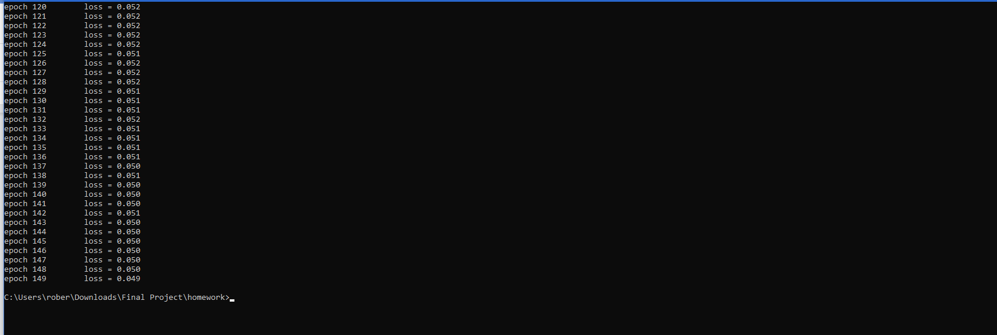

Planner 3

C:\Users\rober\Downloads\Final Project\homework>python -m train

epoch 0 loss = 0.121

epoch 1 loss = 0.113

epoch 2 loss = 0.113

epoch 3 loss = 0.112

epoch 4 loss = 0.111

epoch 5 loss = 0.111

epoch 6 loss = 0.111

epoch 7 loss = 0.110

epoch 8 loss = 0.110

epoch 9 loss = 0.109

epoch 10 loss = 0.108

epoch 11 loss = 0.105

epoch 12 loss = 0.103

epoch 13 loss = 0.098

epoch 14 loss = 0.095

epoch 15 loss = 0.092

epoch 16 loss = 0.090

epoch 17 loss = 0.085

epoch 18 loss = 0.084

epoch 19 loss = 0.082

epoch 20 loss = 0.079

epoch 21 loss = 0.078

epoch 22 loss = 0.077

epoch 23 loss = 0.075

epoch 24 loss = 0.074

epoch 25 loss = 0.073

epoch 26 loss = 0.073

epoch 27 loss = 0.071

epoch 28 loss = 0.071

epoch 29 loss = 0.070

epoch 30 loss = 0.069

epoch 31 loss = 0.068

epoch 32 loss = 0.068

epoch 33 loss = 0.067

epoch 34 loss = 0.067

epoch 35 loss = 0.066

epoch 36 loss = 0.065

epoch 37 loss = 0.065

epoch 38 loss = 0.064

epoch 39 loss = 0.064

epoch 40 loss = 0.063

epoch 41 loss = 0.062

epoch 42 loss = 0.062

epoch 43 loss = 0.062

epoch 44 loss = 0.061

epoch 45 loss = 0.061

epoch 46 loss = 0.061

epoch 47 loss = 0.060

epoch 48 loss = 0.060

epoch 49 loss = 0.059

epoch 50 loss = 0.058

epoch 51 loss = 0.058

epoch 52 loss = 0.058

epoch 53 loss = 0.058

epoch 54 loss = 0.057

epoch 55 loss = 0.057

epoch 56 loss = 0.057

epoch 57 loss = 0.056

epoch 58 loss = 0.056

epoch 59 loss = 0.056

epoch 60 loss = 0.055

epoch 61 loss = 0.056

epoch 62 loss = 0.055

epoch 63 loss = 0.054

epoch 64 loss = 0.054

epoch 65 loss = 0.054

epoch 66 loss = 0.053

epoch 67 loss = 0.053

epoch 68 loss = 0.053

epoch 69 loss = 0.053

epoch 70 loss = 0.052

epoch 71 loss = 0.052

epoch 72 loss = 0.053

epoch 73 loss = 0.052

epoch 74 loss = 0.051

epoch 75 loss = 0.051

epoch 76 loss = 0.051

epoch 77 loss = 0.050

epoch 78 loss = 0.051

epoch 79 loss = 0.050

epoch 80 loss = 0.050

epoch 81 loss = 0.050

epoch 82 loss = 0.050

epoch 83 loss = 0.050

epoch 84 loss = 0.049

epoch 85 loss = 0.049

epoch 86 loss = 0.049

epoch 87 loss = 0.048

epoch 88 loss = 0.049

epoch 89 loss = 0.048

epoch 90 loss = 0.047

epoch 91 loss = 0.048

epoch 92 loss = 0.048

epoch 93 loss = 0.048

epoch 94 loss = 0.048

epoch 95 loss = 0.047

epoch 96 loss = 0.047

epoch 97 loss = 0.047

epoch 98 loss = 0.046

epoch 99 loss = 0.046

epoch 100 loss = 0.046

epoch 101 loss = 0.046

epoch 102 loss = 0.046

epoch 103 loss = 0.045

epoch 104 loss = 0.046

epoch 105 loss = 0.045

epoch 106 loss = 0.045

epoch 107 loss = 0.046

epoch 108 loss = 0.045

epoch 109 loss = 0.045

epoch 110 loss = 0.045

epoch 111 loss = 0.044

epoch 112 loss = 0.044

epoch 113 loss = 0.044

epoch 114 loss = 0.045

epoch 115 loss = 0.043

epoch 116 loss = 0.044

epoch 117 loss = 0.044

epoch 118 loss = 0.044

epoch 119 loss = 0.044

epoch 120 loss = 0.044

epoch 121 loss = 0.043

epoch 122 loss = 0.043

epoch 123 loss = 0.043

epoch 124 loss = 0.043

epoch 125 loss = 0.043

epoch 126 loss = 0.042

epoch 127 loss = 0.043

epoch 128 loss = 0.043

epoch 129 loss = 0.043

epoch 130 loss = 0.043

epoch 131 loss = 0.042

epoch 132 loss = 0.042

epoch 133 loss = 0.042

epoch 134 loss = 0.041

epoch 135 loss = 0.041

epoch 136 loss = 0.042

epoch 137 loss = 0.042

epoch 138 loss = 0.042

epoch 139 loss = 0.041

epoch 140 loss = 0.041

epoch 141 loss = 0.041

epoch 142 loss = 0.041

epoch 143 loss = 0.041

epoch 144 loss = 0.041

epoch 145 loss = 0.041

epoch 146 loss = 0.041

epoch 147 loss = 0.041

epoch 148 loss = 0.040

epoch 149 loss = 0.041

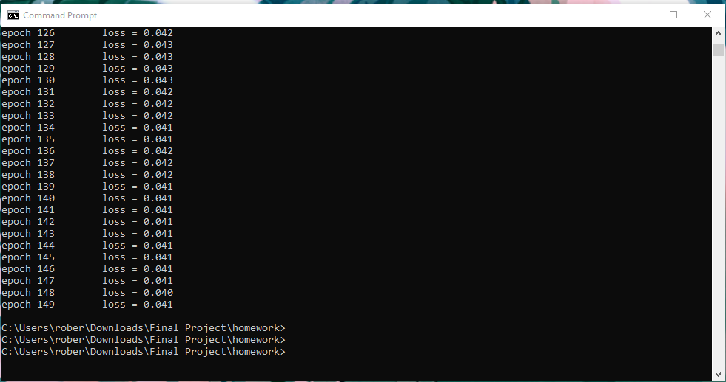

Justin Planner 4

C:\Users\rober\Downloads\Final Project\homework>python -m train

epoch 0 loss = 0.121

epoch 1 loss = 0.115

epoch 2 loss = 0.115

epoch 3 loss = 0.115

epoch 4 loss = 0.115

epoch 5 loss = 0.115

epoch 6 loss = 0.114

epoch 7 loss = 0.115

epoch 8 loss = 0.114

epoch 9 loss = 0.114

epoch 10 loss = 0.114

epoch 11 loss = 0.114

epoch 12 loss = 0.114

epoch 13 loss = 0.114

epoch 14 loss = 0.114

epoch 15 loss = 0.114

epoch 16 loss = 0.114

epoch 17 loss = 0.114

epoch 18 loss = 0.114

epoch 19 loss = 0.113

epoch 20 loss = 0.113

epoch 21 loss = 0.113

epoch 22 loss = 0.113

epoch 23 loss = 0.113

epoch 24 loss = 0.113

epoch 25 loss = 0.113

epoch 26 loss = 0.113

epoch 27 loss = 0.112

epoch 28 loss = 0.113

epoch 29 loss = 0.112

epoch 30 loss = 0.112

epoch 31 loss = 0.112

epoch 32 loss = 0.112

epoch 33 loss = 0.112

epoch 34 loss = 0.112

epoch 35 loss = 0.112

epoch 36 loss = 0.112

epoch 37 loss = 0.112

epoch 38 loss = 0.111

epoch 39 loss = 0.112

epoch 40 loss = 0.112

epoch 41 loss = 0.112

epoch 42 loss = 0.111

epoch 43 loss = 0.112

epoch 44 loss = 0.111

epoch 45 loss = 0.112

epoch 46 loss = 0.111

epoch 47 loss = 0.111

epoch 48 loss = 0.111

epoch 49 loss = 0.111

epoch 50 loss = 0.111

epoch 51 loss = 0.111

epoch 52 loss = 0.111

epoch 53 loss = 0.111

epoch 54 loss = 0.111

epoch 55 loss = 0.111

epoch 56 loss = 0.111

epoch 57 loss = 0.111

epoch 58 loss = 0.111

epoch 59 loss = 0.111

epoch 60 loss = 0.111

epoch 61 loss = 0.111

epoch 62 loss = 0.110

epoch 63 loss = 0.110

epoch 64 loss = 0.110

epoch 65 loss = 0.110

epoch 66 loss = 0.110

epoch 67 loss = 0.110

epoch 68 loss = 0.110

epoch 69 loss = 0.109

epoch 70 loss = 0.110

epoch 71 loss = 0.109

epoch 72 loss = 0.109

epoch 73 loss = 0.109

epoch 74 loss = 0.108

epoch 75 loss = 0.108